CHORLEY HOSPITAL: Please contact St Joseph's Presbytery, 01257 262713, if any member of your family is admitted into Chorley Hospital and would appreciate a visit. In an emergency ask the staff to get the hospital switchboard to contact immediately the on-call Catholic Priest.
ST ANNE’S GUILD: next bingo is on Tues 28th Nov at 19.45 in the Parish Centre.
BAPTISMS: In order to arrange a baptism, please see Fr Marsden or Deacon Norman after one of the Sunday Masses.
FRIDAY FILM SESSIONS: We meet on Friday 1st December at 14.00. The film is about the Martyr St John Houghton, abbot of the London Charterhouse, a Carthusian monk, who was one of the first victims of Henry VIII’s persecution of all who would not go along with his takeover of the Church in England.
CHRISTMAS CARDS are quickly selling out. All cards and advent calendars and Catholic diaries are traditional and religious. They have been bought at excellent prices from St Rita’s Convent in Honiton. When there’re gone – there’re gone!
SACRAMENTAL PROGRAMME FIRST CONFESSIONS; will take place on Tuesday 5th December at 18.00 in the school. Parents and grandparents are most welcome. The next catechesis with preparation for confessions is on Sunday 3rd December. There are 36 children preparing for the Sacraments this year. Please keep them and their families in your prayers. Thank you.

ADVENT EVENING OF RECOLLECTION FOR MEN - an excellent preparation for Christmas. A “mini-retreat” for men Tuesday 5 December 2017, 8.00pm - 9.30pm in St Joseph's Church, Bolton Road, Anderton (Adlington), Chorley PR6 9NA. Further information from Robert Aston Tel. 01204 468896.

WORLD YOUTH DAY is today. Please offer your rosaries for young people and their families. Our Little Church group will say a ‘Hail Mary’ for all the children in the world who need that ‘something special’ and during the prayers, outside the church, the children will let off 12 bio-degradable balloons, for the 12 Apostles, for World Youth Sunday, with a prayer and message attached. How far will these balloons fly?

LITTLE CHURCH ADVENT DATES AND DETAILS ARE AVAILABLE ON THE POSTER IN THE NARTHEX

ST MARY’S FRIENDS OF UGANDA: raised £156 from the Craft and Gift fundraiser which was held on the 18th November. Thank you to everyone who contributed and supported the event. Also there will be a Prize Bingo Sunday 26th Nov at 18.30 at St Joseph’s Chorley Parish Centre. Everyone most welcome.

SVP CHRISTMAS PARTY for the housebound, sick and elderly on Saturday 2nd December at 13.30 in the Parish Centre.

Fr Francis Marsden and Deacon Norman Arrowsmith
E-mail address: stmaryschorley@yahoo.co.uk
Tel: 01257 262537
Parish website: www.stmarys-chorley.org

Parish Office hours: Tues. Thurs, Fri. 09.30-11.55 and 2- 4. Wed. 10-1 and 2-4.
OUTSIDE OF THESE TIMES BY APPOINTMENT ONLY

Parish Centre: 270122 or 07971025 985 (Manager – Heather Roscoe)

LIVERPOOL ROMAN CATHOLIC ARCHDIOCESAN TRUSTEES INC. Registered Charity No. 232709
St Mary’s Catholic Church Chorley

OUR LORD JESUS CHRIST, UNIVERSAL KING

26th November 2017
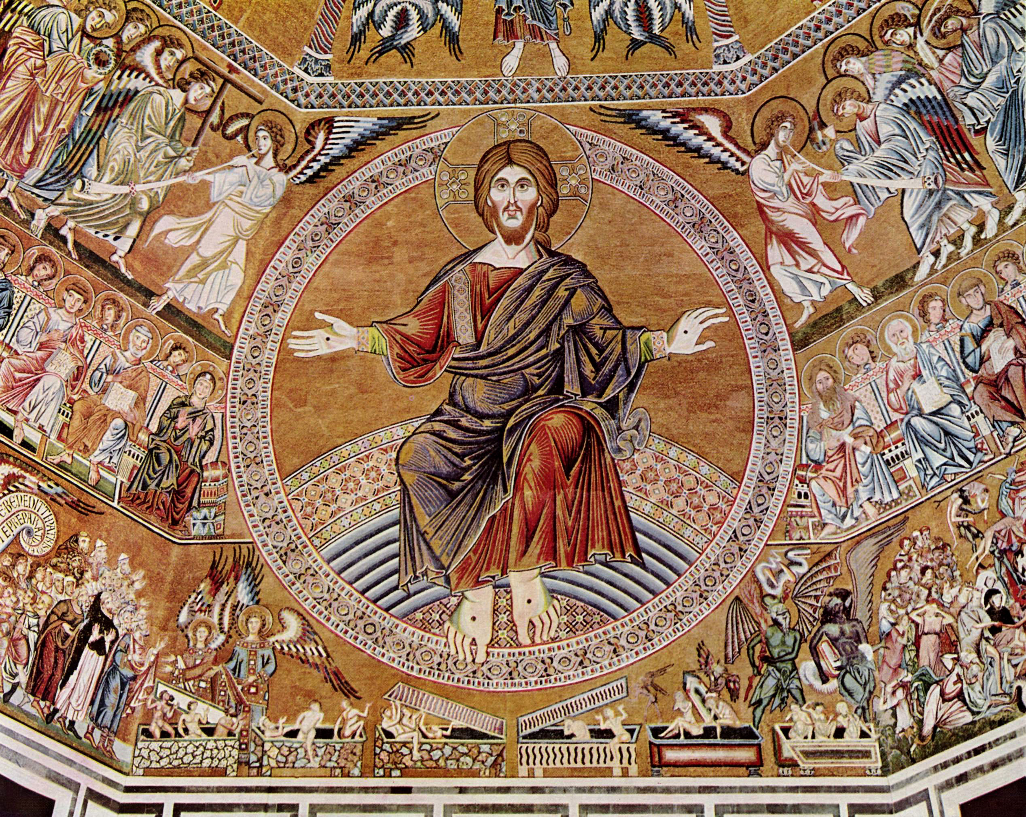
Jesus said to his disciples: ‘When the Son of Man comes in his glory, escorted by all the angels, then he will take his seat on his throne of glory. All the nations will be assembled before him and he will separate men one from another as the shepherd separates sheep from goats. He will place the sheep on his right hand and the goats on his left.
‘Then the King will say to those on his right hand, “Come, you whom my Father has blessed, take for your heritage the kingdom prepared for you since the foundation of the world. For I was hungry and you gave me food; I was thirsty and you gave me drink; I was a stranger and you made me welcome; naked and you clothed me, sick and you visited me, in prison and you came to see me.” Then the virtuous will say to him in reply, “Lord, when did we see you hungry and feed you; or thirsty and give you drink? When did we see you a stranger and make you welcome; naked and clothe you; sick or in prison and go to see you?” And the King will answer, “I tell you solemnly, in so far as you did this to one of the least of these brothers of mine, you did it to me.”
‘Next he will say to those on his left hand, “Go away from me, with your curse upon you, to the eternal fire prepared for the devil and his angels. For I was hungry and you never gave me food; I was thirsty and you never gave me anything to drink; I was a stranger and you never made me welcome, naked and you never clothed me, sick and in prison and you never visited me.” Then it will be their turn to ask, “Lord, when did we see you hungry or thirsty, a stranger or naked, sick or in prison, and did not come to your help?” Then he will answer, “I tell you solemnly, in so far as you neglected to do this to one of the least of these, you neglected to do it to me.”
‘And they will go away to eternal punishment, and the virtuous to eternal life.’

Sun 26th OUR LORD JESUS CHRIST, UNIVERSAL KING (pg.158)
Sat. 18.15 Mass – Eddie McCrory (A)
08.00 Mass – Pious List
10.30 Mass – Parishioners
14.00 Msza Święta po polsku
16.00 Holy Hour – Exposition, Evening Prayer at 16.30, then Benediction

Mon 27th
08.40 Morning Prayer
09.00 Mass – Pious List

Tues 28th St Catherine Labouré
09.30 Morning Prayer
12.00 Mass– Pious List
15.00 Requiem Mass – Peter Christopher Nelson

Wed 29th St Cuthbert Mayne
08.40 Morning Prayer
09.00 Mass – Pious List
11.00 Deanery Meeting

Thurs 30th ST ANDREW, APOSTLE
12.00 Mass – Pious List

Fri 1st Dec Ss Ralph Sherwin, Alexander Briant & Edmund Campion
09.30 – 11.45 Morning Prayer and Exposition
12.00 Mass – Bernard (A) and Alice Joyce

Sat 2nd

11.00 – 11.45 Confessions
12.00 Mass – Mary Baxendale (A)
13.30 SVP Christmas Party at Parish Centre

Sun 3rd FIRST SUNDAY OF ADVENT (p.82)
Sat.18.15 Mass – Leo, Rosie, Janet and Michael Bolton RIP
08.00 Mass – Parishioners
10.30 Mass – Bernard and Marie Worden RIP
11.45 – 12.45 Yr 4 Sacramental Catechesis
16.00 Holy Hour – Exposition and
16.30 Evening Prayer & Benediction

Rosary daily after midday Mass

Please pray for the sick and the housebound: Emily Atkins, Emma Beatty, Pauline Bennett, Margaret Bower, Brigid Cain, Christine Caunce, Michael Carter, John Cheyne, Colin Clarke, Helen Collins, Michael Collins, Melville Coombes, Mgr Bill Dalton, Hughie Daly, Joan Doran, Sr Frances, Sr Paschal, Mavis Entwistle, Grace (14), Yvonne Finlayson, Mildred Gilhooley, Desmond Gorman, John Green, Martin Henry, John Johnson, Joan Jones, Lynda Keeley, Bernard Kenyon, Doreen Lang, Fr Tom Leigh, Julie Lowe, Richard Lowe, Tusia Lynch, Debbie MacFarlane, Kevin McCarrick, Frances McHale, Kathleen Mitchell, Veronica Mobbs, Catherine O’Donoghue, Anthony O’Malia, Nora O’Neill, Edna Penman, Margaret Rice, Canon Bert Shaw, Mgr. Jan Szponar, Maureen Taylor, Paul Tiffin, Terry Tingey, Bridget Trimm, Muriel Wilson, Frank Waring, Agnes Young and parishioners in The Adelphi, The Gables, Westwood, Gillibrand Hall.

RECENTLY DECEASED: Peter Christopher Nelson (67) who died on 17th November in St Catherine’s Hospice. Requiem Mass this Tuesday at 15.00 followed by cremation at Charnock Richard. Eternal rest grant unto him, O Lord…..
ANNIVERSARIES: Eddie McCrory, Bernard Joyce, Mary Baxendale,
READERS: 25/26 Nov: 18.15 Stan Wilson; 08.00 John Gunn; 10.30 John Daniels 2/3 Dec:: 18.15: Angela Simm; 08.00: Kath Jackson; 10.30: Dr Jane Eccles.
OFFERTORY COLLECTION last week was £803 of which £509 was gift aided. This weekend is the retiring collection for Animate – the Archdiocesan Youth Service. Thank you for your great generosity.

ADVENT IS COMING SOON: Advent is a time for preparation for the birth of Our Lord Jesus Christ. For many people, it is a time for buying, shopping, planning, getting together with loved ones and putting up decorations and Christmas Trees. Many people forget or leave out Our Blessed Lord. Christmas is about Christ, The Saviour of Mankind and our Salvation. The pathway to the town centre goes past our church. We see the coming and going of hundreds of people, laden with bags, full of shopping and gifts. How many stop and pop into church to say a prayer and take a spiritual breath? ‘No time, got to rush, I am too busy’. The church is open all day, 9 am to dusk, just for you! You will be welcome.

PRAYERS TO CHRIST THE KING
This prayer to Christ the King gives us an answer to the often-asked question “Who’s in charge here”! When we say that “I am the captain of my ship, the master of my soul,” but don’t seek God’s guidance, our boat is often in danger of capsizing in life’s stormy waters:

Christ Jesus, I acknowledge You King of the universe. All that has been created has been made for You. Make full use of Your rights over me.
I renew the promises I made in Baptism, when I renounced Satan and all his pomps and works, and I promise to live a good Christian life and to do all in my power
to procure the triumph of the rights of God and Your Church.
Divine Heart of Jesus, I offer you my efforts in order to obtain that all hearts may acknowledge your Sacred Royalty, and that thus the Kingdom of Your peace
may be established throughout the universe. Amen.

Pope Pius XI instituted the feast of Christ the King in 1925 to combat the disturbing growth of secular, atheistic thinking around the world. Many rulers and elites in various countries had fallen prey to the notion that mankind could manage just fine without God, thank you. They relegated our Creator to an insignificant role in public life or to no role at all, as in the USSR. When we kick God out of our lives, our world becomes more turbulent and dangerous, not less. We end up worshipping the false gods of money, power, sex and celebrity instead. As St. James said "where there is envy and contentiousness there is instability and every wicked deed" (James 3:16). Forgetting God’s commandments, we become more vulnerable to enslavement by lying despots, dictators who seek to make themselves gods, much like the Archangel Lucifer when he rebelled against our Creator saying “I will not serve.”

Almighty, everlasting God, Who in Thy beloved Son, King of the whole world, hast willed to restore all things anew; grant in Thy Mercy that all the families of nations,
rent asunder by the wound of sin, may be subjected to His most gentle rule. Who with Thee lives and reigns world without end. Amen.

ADVENT CALENDARS AND SAUSAGE ROLLS – You may wish to consider buying your pasties and bread from somewhere other than Greggs, who produced an Advent Calendar which, when you opened its final door, shows a manger containing a sausage roll surrounded by the Magi. Stupid, disrespectful and irreverent! They “apologized” but haven’t withdrawn the calendar. No doubt it got them the publicity they wanted. Several Christian groups have advocated a boycott.

